EXERCISE 17
1.Find and list the IDs and spouse names of all employees who are married.
SELECT employee_id, spouse_name FROM employee_data WHERE marital_status = 'Y';
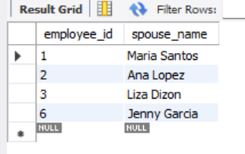

2.Change the above so that the display is sorted by spouse names.
SELECT employee_id, spouse_name FROM employee_data WHERE marital_status = 'Y' ORDER BY spouse_name;

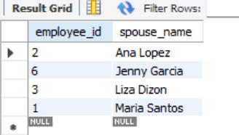

3.How many employees do we have under each sex (male and female)?
SELECT sex, COUNT(*) AS 'Number of Male and Female' FROM employee_data GROUP BY sex;
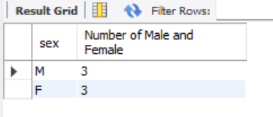

4.How many of our employees are married and unmarried?
SELECT marital_status, COUNT(*) AS 'Number of Married'FROM employee_data GROUP BY marital_status;
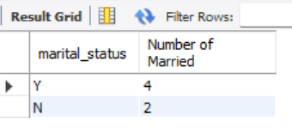

5.Find the total number of children.
SELECT SUM(children) AS 'Total Number of Children' FROM employee_data WHERE children IS NOT NULL;
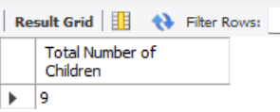

6. Make unique groups of children and find the number in each group.Sort the display so that the group with maximum children is at the top.
SELECT children, COUNT(*) AS 'Children Count' FROM employee_data WHERE children IS NOT NULL GROUP BY children ORDER BY children DESC;
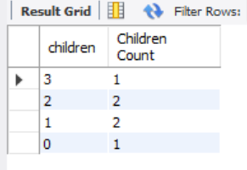

CREATE DATABASE EXERCISE17_ADDRESSBOOK;
USE EXERCISE17_ADDRESSBOOK;
CREATE TABLE employee_data (
employee_id INT AUTO_INCREMENT PRIMARY KEY,
f_name VARCHAR(100),
l_name VARCHAR(100),
birth_date DATE,
email VARCHAR(150),
spouse_name VARCHAR(100),
marital_status CHAR(1),
children INT,
sex CHAR(1)
);
INSERT INTO employee_data (f_name, l_name, birth_date, email, spouse_name, marital_status, children, sex) VALUES
('Kim', 'Mariano', '1950-05-12', 'kim.mariano@email.com', 'Maria Santos', 'Y', 3, 'M'),
('Trisha', 'Kim', '1962-03-18', 'trisha.kim@email.com', 'Ana Lopez', 'Y', 2, 'F'),
('Kim', 'Etucag', '1971-07-22', 'kim.etucag@email.com', 'Liza Dizon', 'Y', 1, 'M'),
('Daniel', 'Aguilar', '1970-11-10', 'daniel.aguilar@email.com', NULL, 'N', 0, 'M'),
('Mariel', 'Blue', '1972-01-29', 'mariel.blue@email.com', NULL, 'N', 1, 'F'),
('Hazel', 'Tolentino', '1980-02-14', 'hazel.tolentino@email.com', 'Jenny Garcia', 'Y', 2, 'F');

SELECT employee_id, spouse_name FROM employee_data WHERE marital_status = 'Y';
SELECT employee_id, spouse_name FROM employee_data WHERE marital_status = 'Y' ORDER BY spouse_name;
SELECT sex, COUNT(*) AS 'Number of Male and Female' FROM employee_data GROUP BY sex;
SELECT marital_status, COUNT(*) AS 'Number of Married'FROM employee_data GROUP BY marital_status;
SELECT SUM(children) AS 'Total Number of Children' FROM employee_data WHERE children IS NOT NULL;
SELECT children, COUNT(*) AS 'Children Count' FROM employee_data WHERE children IS NOT NULL GROUP BY children ORDER BY children DESC;

